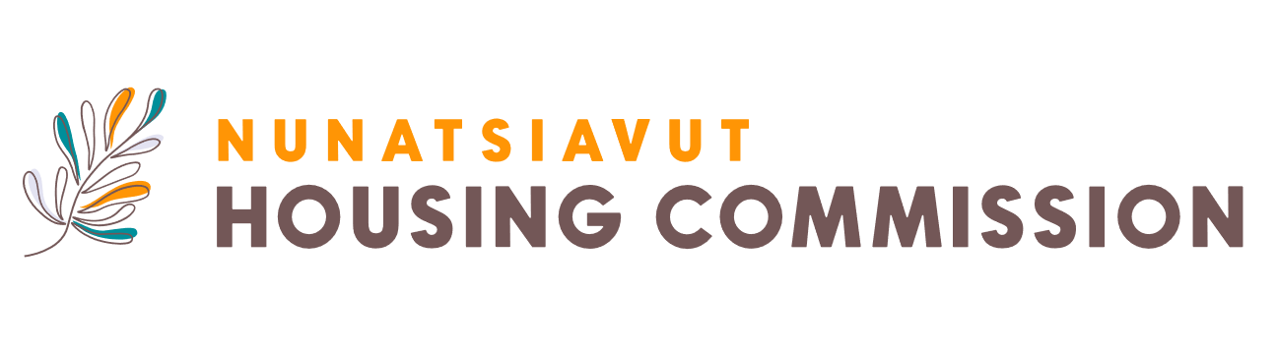

**Job Description Maintenance**

Reporting to the Maintenance Manager, the Maintenance Worker is responsible for performing a variety of maintenance and repair tasks to ensure the proper upkeep and functionality of residential properties managed by the Nunatsiavut Housing Commission. This role involves routine maintenance (i.e., carpentry, plumbing, electrical), responding to repair requests (trouble shooting and problem solving), and ensuring properties meet safety and quality standards.

**The Opportunity**:

This role involves preparing detailed inspection reports, documenting findings, and maintaining organized records of all inspections and completed work. You ensure properties comply with housing codes and follow up on corrective actions to maintain compliance. Responsibilities include performing routine maintenance on building systems like plumbing, electrical, and structural components, as well as handling carpentry, painting, and exterior repairs. You ensure common areas and grounds are well-maintained and safe, and report any safety hazards or code violations. This role is also required to manage inventory, maintain tools and equipment, and restock supplies as needed.

**Who You Are:**

The ideal candidate will possess a high school diploma or equivalent, vocational training in maintenance or related fields is considered an asset. You will have 1-3 years of previous experience in general maintenance, repair or construction work. You will possess knowledge of building maintenance, electrical, and plumbing systems, as well as familiarity with building codes and regulations. You are able to maintain tenant confidentiality, have strong problem-solving skills, and attention to detail. The role requires the safe and effective use of hand and power tools, good communication and interpersonal skills, and the ability to work both independently and as part of a team. Familiarity with Inuit culture is highly desirable. Bilingual ability in Inuktitut and English is considered an asset.

**Location**: Nain, Rigolet, Makkovik, Postville

To apply for this opportunity, please submit your resume to: [recruitment@mcadvisory.com](mailto:recruitment@mcadvisory.com).

*The Nunatsiavut Housing Commission is committed to building an environment that is diverse and inclusive, representative of the communities in which we serve. If you have a disability and require an accommodation(s) to participate in the application, interviewing or selection process, please contact recruitment@mcadvisory.com.*

We appreciate all applicants; however, only those selected for an interview will be contacted.

**Deadline for applications:** November 29th, 2024