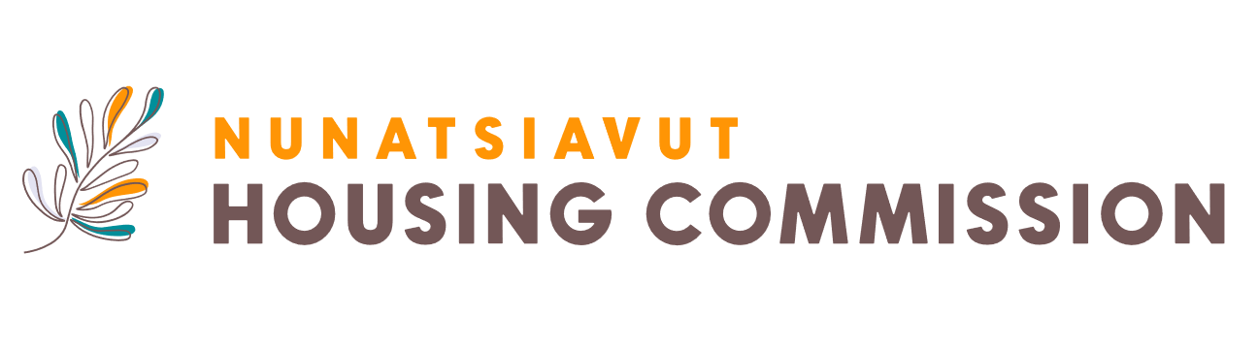

**Job Description Finance Manager**

The Finance Manager reports to the Director of Housing. The Finance Manager for the Nunatsiavut Housing Commission (NHC) will oversee all aspects of financial management, including budgeting, financial reporting and internal controls. As part of the management team, the Finance Manager drives financial stability of the NHC while the NHC delivers essential housing programs throughout the Nunatsiavut Region.

**The Opportunity**:

The Finance Manager for the NHC will be responsible for establishing accounting policies, internal financial controls, and financial systems. This role includes comprehensive financial management, such as maintaining the general ledger, preparing financial statements, managing payroll, budgeting, and cash flow for both operations and capital projects. The Finance Manager will oversee reconciliations, ensure effective financial planning, and identify areas for process improvement. Additionally, they will assist in preparing Business Plans and 5-year Financial Plans, prepare monthly financial reports for government bodies and the Board of Commissioners, and coordinate with external accountants and auditors for annual financial statements.

**Who You Are:**

The ideal candidate for the Finance Manager position at the NHC will hold a Bachelor's degree in business, commerce, accounting, finance, or a related field, with a minimum of 5+ years of experience in a senior accounting role. They will possess a strong knowledge of financial management, accounting principles, payroll software, budget oversight, and financial reporting, ideally within a government or government agency context. The candidate will demonstrate excellent oral and written communication skills, along with strong interpersonal abilities, enabling them to lead and manage teams effectively. Exceptional analytical skills, proficiency in accounting software and Microsoft Office, and a talent for building and maintaining strong relationships with staff are also essential. The candidate will be a competent problem solver, skilled in team building, planning, and decision-making. Bilingual in Inuktitut and English is an asset.

**Location**: Nain, Rigolet, Hopedale, Makkovik, Postville

To apply for this opportunity, please submit your resume to: [recruitment@mcadvisory.com](mailto:recruitment@mcadvisory.com).

*The Nunatsiavut Housing Commission is committed to building an environment that is diverse and inclusive, representative of the communities in which we serve. If you have a disability and require an accommodation(s) to participate in the application, interviewing or selection process, please contact recruitment@mcadvisory.com.*

We appreciate all applicants; however, only those selected for an interview will be contacted.

**Deadline for applications:** November 29th, 2024